|  |  |
| --- | --- |
|  | |
|  | |
| Concept Selection Report  Group 13 | |
| **Module code:** | **EG2005** |
| **Module name:** | **Engineering Design 2** |
|  | |
| [Date of submission] | |
|  | |
| **Author(s):** | **Paul Longe, Divine Abraham, Alexandros Agrafiotis, Bradley Blocksidge, Keqi Shu, Xiang Zhang** |
| **Student ID(s):** | **[Number]** |
| **Managers:** | **Tom Gibbs, Sameera S. Fernando** |
| **Degree:** |  |
| **Tutor/Project supervisor:** | **[Name]** |
|  | |

Contents

1 Introduction – Paul Longe 0

1.1 List of members and Responsibilities 0

1.1 Chassis Engineer – Bradley Blocksidge 0

1.2 Design Engineer - Alexandros Agrafiotis 0

1.3 Powertrain Engineer – Keqi Shu 0

1.4 Integration Engineer – Paul Longe 0

1.5 Electrical Engineer – Divine Abraham 0

1.6 Payload Specialist – Xiang Zhang 0

2 Design Criteria – Bradley Blocksidge 0

3 Requirement Tree – Divine Abraham 0

4 Morphological Diagram – Keqi Shu 0

Blaaaaaa 0

5 Initial Concepts – Individual task 0

5.1 Chassis Design- Bradley Blocksidge 0

5.2 Materials and Fan selection- Alexandros Agrafiotis 0

5.3 Powertrain – Keqi Shu 0

5.4 Turning Mechanism - Paul Longe 0

5.5 Electrical Systems – Divine Abraham 0

5.6 Payload – Xiang Zhang 0

6 Synthesis chart Sort of VDP2 {Do together on monday} 0

7 Materials & Pricing - Alexandros Agrafiotis 0

8 Conclusion on design After VDP2 – Xiang Zhang 0

8.1 Chassis – Bradley Blocksidge 0

8.2 Fans and Materials selection - Alexandros Agrafiotis 0

8.3 Powertrain – Keqi Shu 0

8.4 Turning Mechanism – Paul Longe 0

8.5 Electrical Control – Divine Abraham 0

8.6 Payload Xiang Zhang 0

# Introduction – Paul Longe

The design task is to design and build a working prototype of a hovercraft as specified in the EG2005 task document, the hovercraft has set maximum dimensions and minimum weight carrying capacity so that it can be used as a model for real world situations. The design quality will be assessed through the following criteria:

1. The vehicle should be able to start/stop as required
2. The hovercraft should be able to move freely over small obstacles of height less than 5 millimetres.
3. The highest Payload Lift Capacity
4. The highest score of payload mass times distance travelled
5. The lowest overall project cost
6. The design process quality assessed by a Panel of VDPs

The hovercraft will travel in a course of dimensions 4.4mx1.2m, and travel over obstacles of a height under 5mm, there is an area with no obstacles where the hovercraft can turn. More points are scored for the amount of laps made and the load carried. 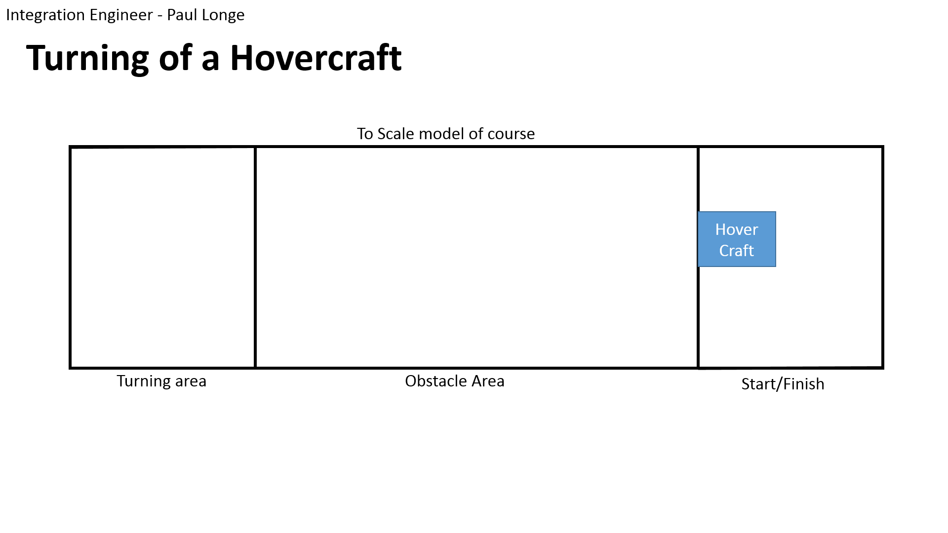

The hovercraft flies on a cushion of air, generated by a lift fan that moves the air at a low speed but high pressure. Because the hovercraft moves on this cushion of air, it experiences very little friction, and is capable as a multi-terrain vehicle. As the friction is small, very little power is required from the thrust fan, so it is also more fuel-efficient then a boat. This makes them extremely suitable for rescue missions, as an amphibious vehicle the hovercraft can operate on: mud flats, sand banks, frozen seas, around shores, and many other places that a boat or car are not able to reach. The hovercraft needs to be able to carry a load which can be people, or medicinal equipment in a rescue situation. This is why the prototype similarly has a minimum load it must be capable of carrying.

## List of members and Responsibilities

## Chassis Engineer – Bradley Blocksidge

3-4sentences  
link back to spec

## Design Engineer - Alexandros Agrafiotis

A design engineer has to to deal with fans, materials and budget. We decided to go with a centrifugal fan for the lift because it produces high pressure in low power. An axial fan is going to be used for thrust. Basic material is going to be the Craft Foam Blue because it is light, strong for our application, easy to change the shape and the price was more than good for the budget we have. The total cost of materials and components is going to be around £184.15. Moreover, safety covers will be made to protect us from the rotating blades and a cover around it so we can prevent any accident.

## Powertrain Engineer – Keqi Shu

3-4sentences Roles and responsibility

## Integration Engineer – Paul Longe

The Integration Engineer is responsible for ensuring that each member of team works together to form a cohesive solution to the problem. The Integration Engineer also had the additional role of designing the mechanical components of control of the hovercraft; with the main priority to ensure that the hovercraft is capable of performing a 180° turn within the 1x1.2m area.

## Electrical Engineer – Divine Abraham

The electrical and control systems engineer is responsible for the design and implementation of the electrical and control systems. The individual has to work closely with the powertrain engineer to deliver a system that is capable of starting and stopping, using a standard radio control system. The system would get enough lift and be capable of overcoming small obstacles and shall travel at a minimum speed of 1.4 m/s.

## Payload Specialist – Xiang Zhang

The Payload Engineer in the group is responsible for design, the appearance of the payload, and for the arrangement and position of each component on the hovercraft, such as fans and load area. At the same time, payload engineer needs to adjust the location of components to help the hovercraft keep balance. Balance is the precondition for running the hovercraft.

# Design Criteria – Bradley Blocksidge

# Requirement Tree – Divine Abraham

Be able to lift off the ground

Change direction

Travel at a minimum speed

Fully Functional Hovercraft

Dimensions

Payload

Materials and manufacture

Safety

Have a payload area

Carry a minimum payload mass of 200g

Carry multiple payloads

Secure payload for restricted movement

Maximum length of 420 mm

Maximum width of 297 mm

Must be enclosed in cowling extending a minimum of 20 mm in front and 20 mm behind the plane of the propeller.

The flexible skirt, propeller, mechanical fixtures and drive components-purchased from university’ preferential suppliers

Control & Propulsion

50%

50%

30%

30%

40%

100%

100%

30%

15%

20%

30%

1.1

1

1.2

1.3

1.4

2.1

2

2.2

2.3

3

4

5

3.1

3.2

4.1

5.1

20%

20%

20%

20%

# Morphological Diagram – Keqi Shu

# Blaaaaaa

**aaaaaaaaah;**

.

# Initial Concepts – Individual task

## Chassis Design- Bradley Blocksidge

## Materials and Fan selection- Alexandros Agrafiotis

|  |  |  |  |  |  |  |  |  |
| --- | --- | --- | --- | --- | --- | --- | --- | --- |
| VDP 1 | | | |  | VDP 2 | | | |
| Fan type | **Feature** | **Properties** | **Material** | **Fan Type** | **Feature** | **Properties** | **Material** |
| First type | 3 short blades | Plastic | Craft Foam Blue | Centrifugal Fan | Produces high pressure in low power | Plastic | Craft Foam Blue |
| Second type | 2 long blades | Carbon |
| Third type | 2 long blades with curves | Plastic |

## Powertrain – Keqi Shu

## Turning Mechanism - Paul Longe

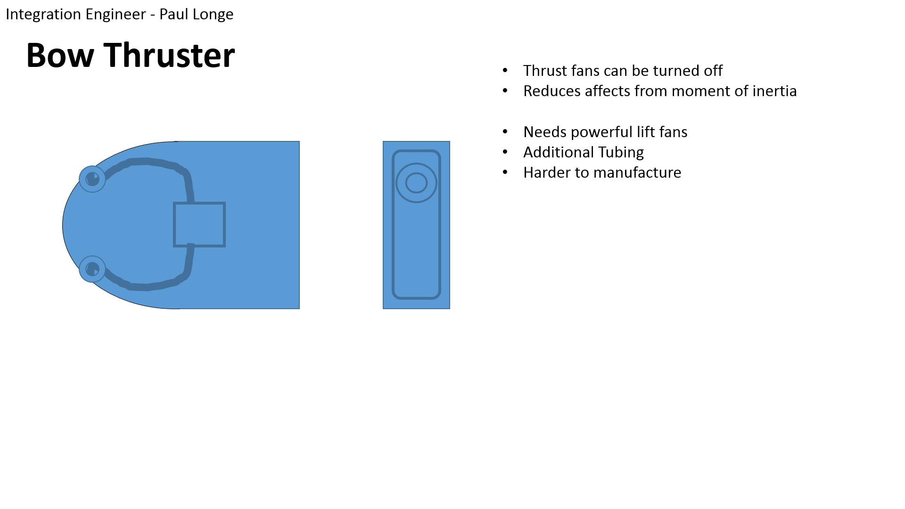**Bow Thrusters (Reference to synthesis Chart 1.1)**One concept was to use bow thrusters to control the craft, the basic idea is to have some of the air from the lift fan redirected through the sides of the craft so as to cause a change in direction through the principle of conservation of momentum. The lift fan needs to be powerful enough to still lift the craft while air is redirected. But a benefit of this idea is that the thrust fan can be turned off whilst the turns are made which will save on power, and reduce the effects caused by moment of inertia which allows the craft to have a smaller radius of turn.

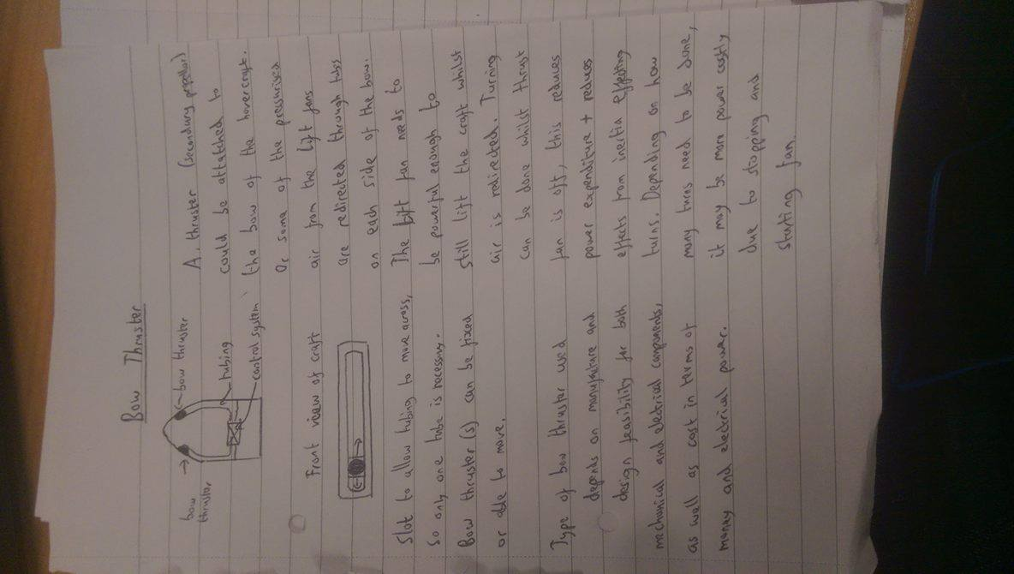

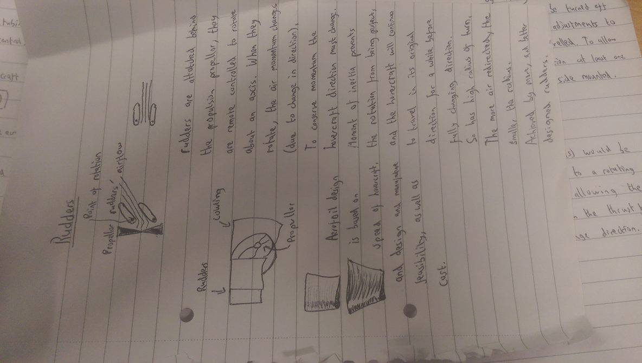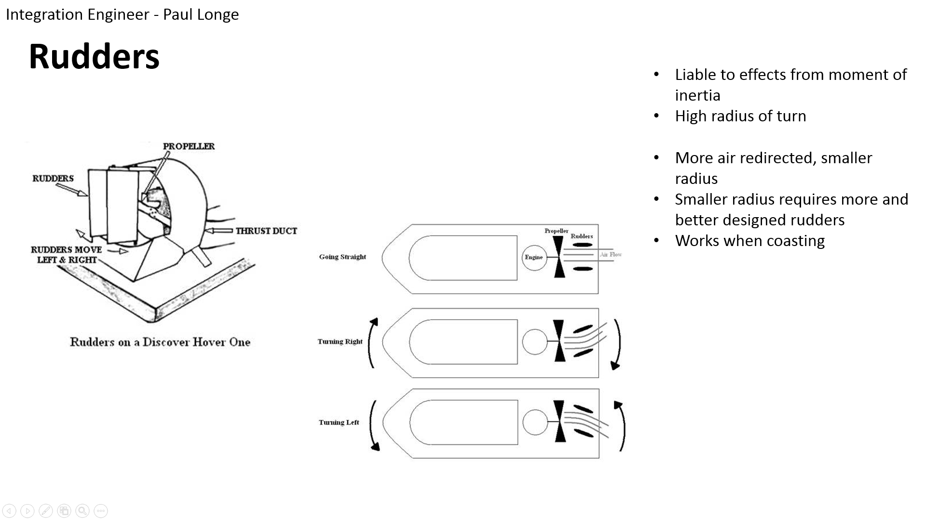**Rudders (Reference to synthesis Chart 1.2)**Another concept was to use rudders to redirect airflow from the thrust fan to control its direction. This would be easier to manufacture and can be freely designed to improve the quality.

**Additional Thrust Fans (Reference to synthesis Chart 1.3)**

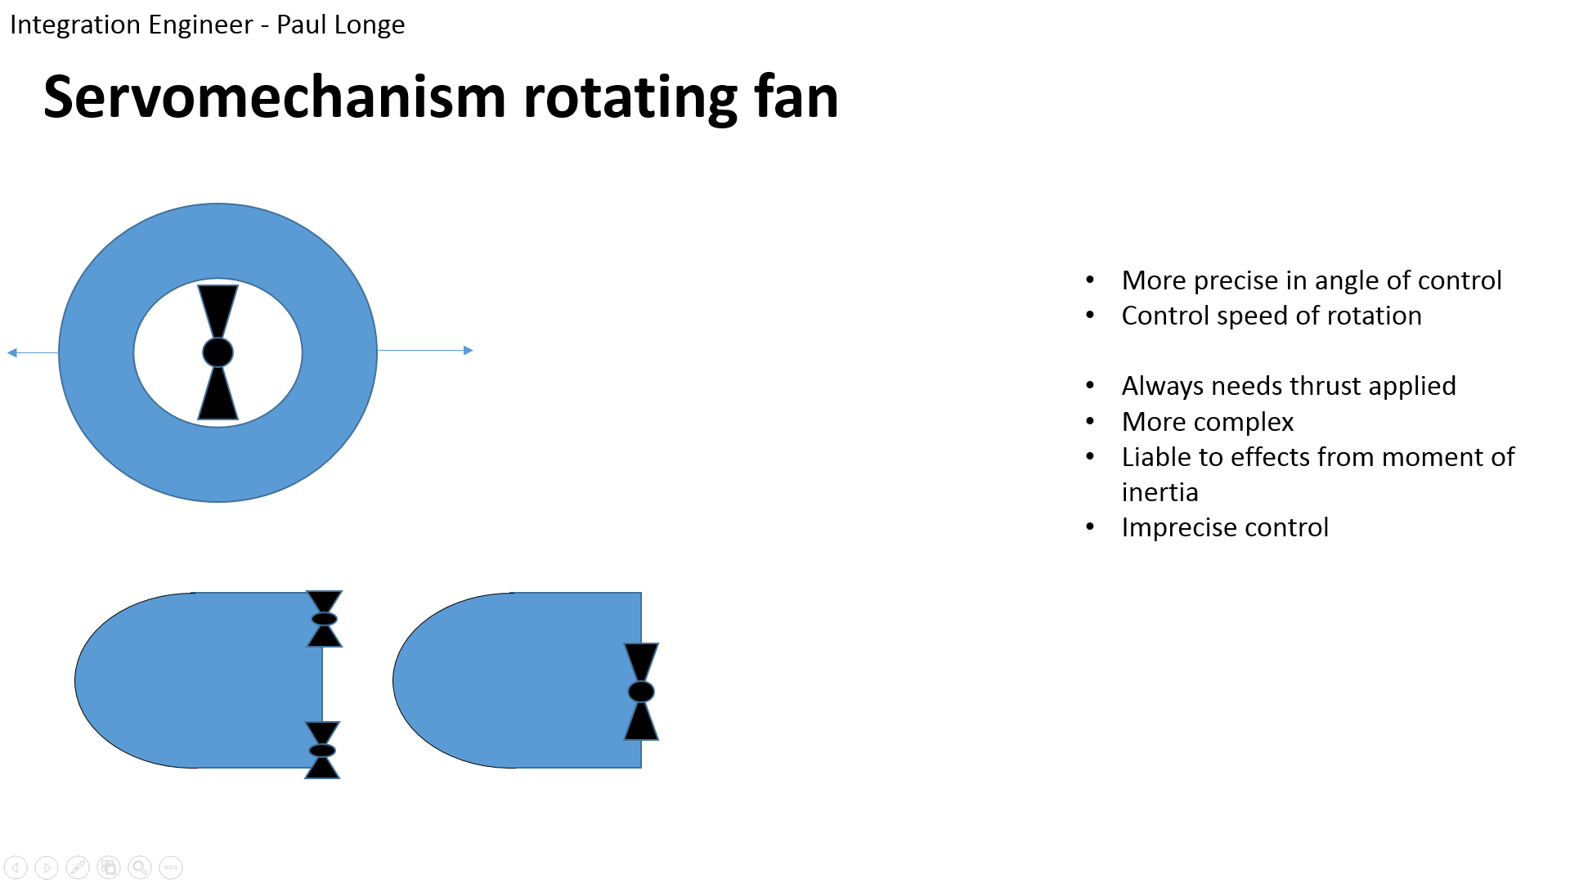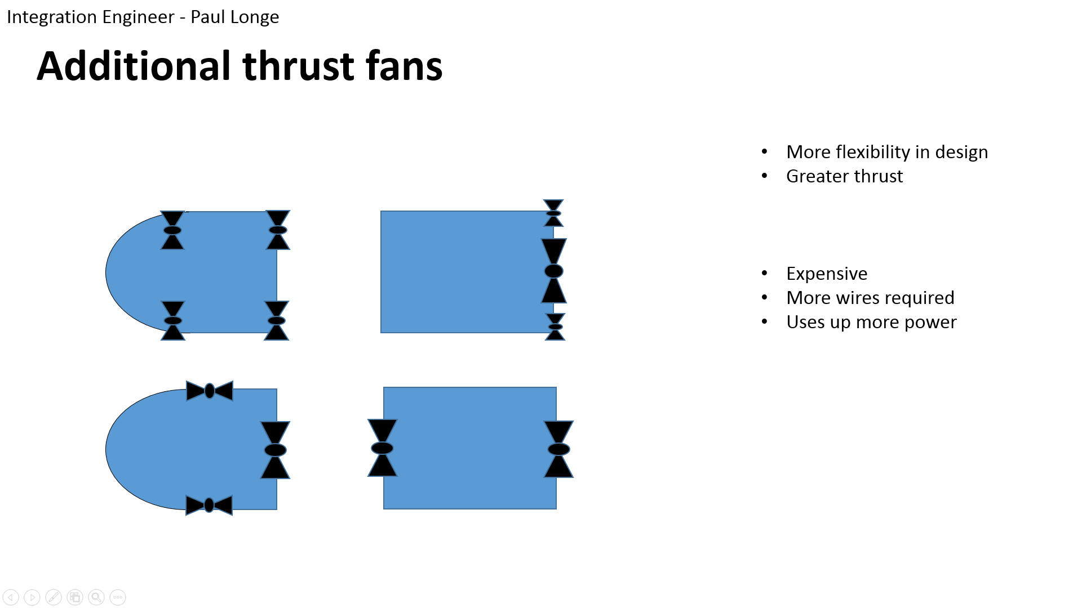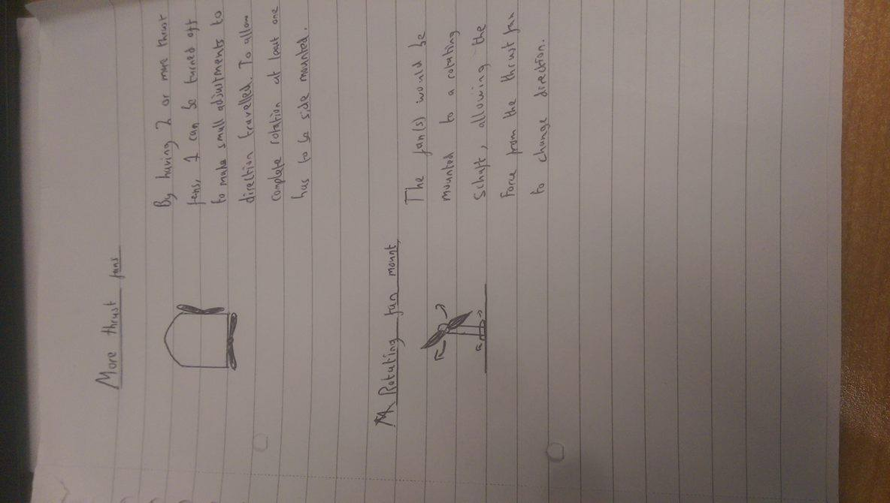 **Rotating Fan(Reference to synthesis Chart 1.4)**

A concept was to use multiple thrust fans thrust fans which allows for several different designs as shown, but may be more expensive in terms of both cost and electrical power. The last concept was the use of a rotating fan, which is more complex to design but allows the hovercraft to stop even if the thrust fan cannot reverse direction.

## Electrical Systems – Divine Abraham

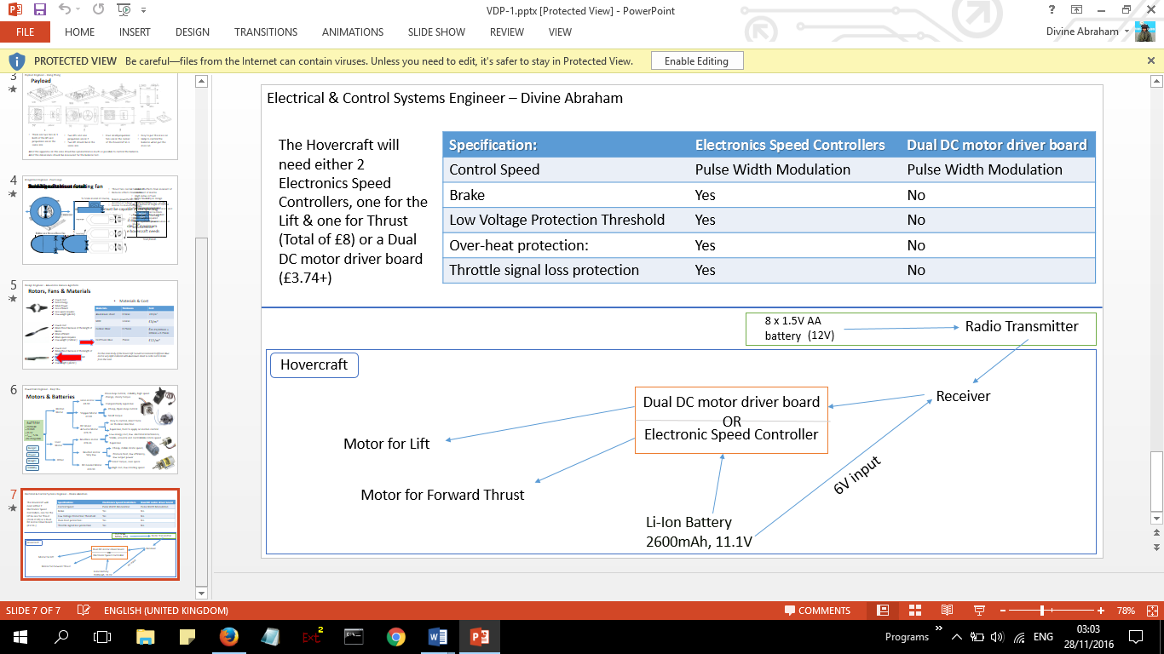At VDP1 there was an option to use either an electronic speed control (ESC’s) **(Reference to synthesis Chart 2.1)** or a Dual DC motor driver board. **(Reference to synthesis Chart 2.2)** The Dual DC motor driver board is cheaper and can control more fans than a single ESC. However after much research and feedback from the design professor it was decided that it would be a better idea to use the ESC’s over the latter as it was cost efficient, easy to work with and requires no additional components for a functioning system.

## Payload – Xiang Zhang

In the VDP 1, we made three hypotheses about the payload area.

In the first hypothesis, there are one propulsion fan and one lift fan. The lift fan is located on the front part and the propulsion fan is located on the pack part of the hovercraft. The load area is on a small table which is placed above the lift fan. The position of a battery is between the lift and the propulsion fan.

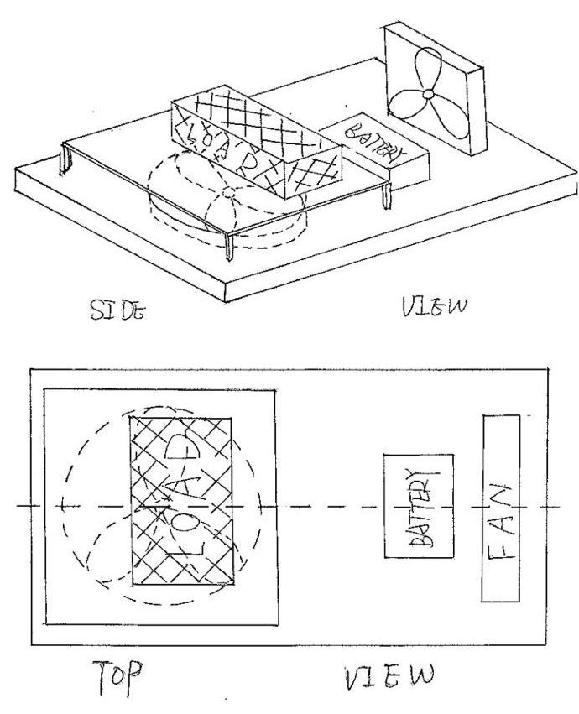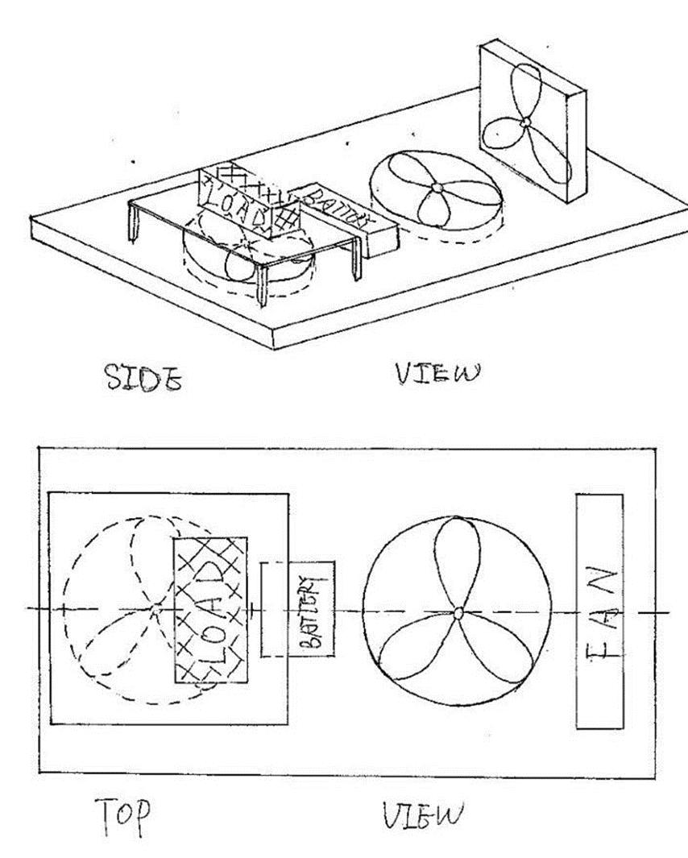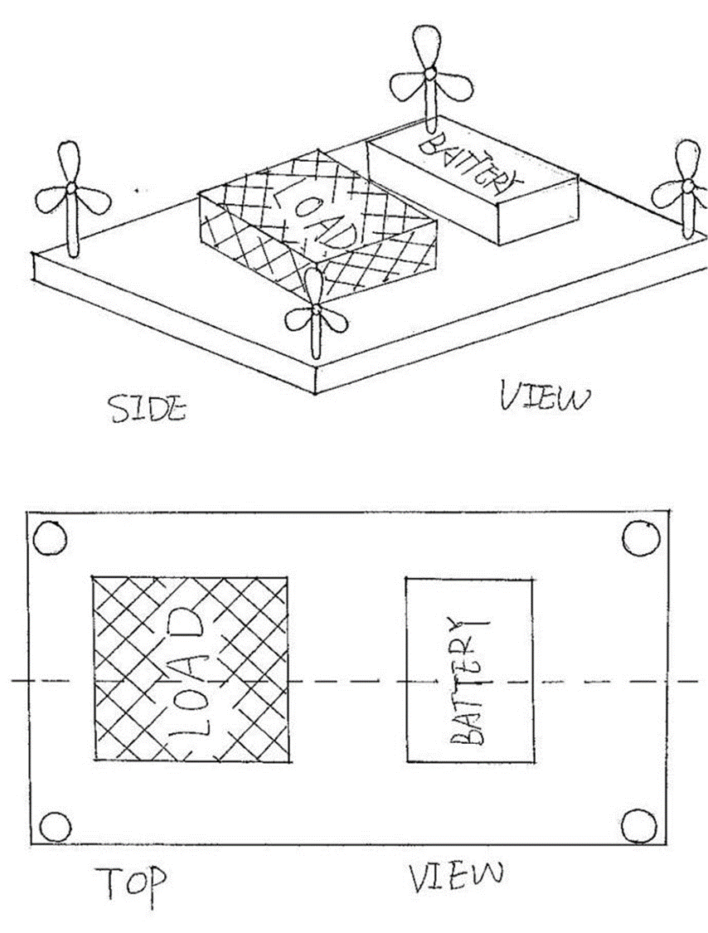

**3.1 3.2 3.3**

**Numbers as referenced in synthesis chart**

In the second one, we designed two lift fans and one propulsion fan. The prolusion fan is in the back part, one of the lift fan is just in front of the back fan the other one is in the upper part. This hypothesis is very similar to the first hypothesis, one more lift is used to help to control the balance.

The last one has four small propulsion fans placed in every corner of the payload area and one lift fan in the front. The load area is just above the lift fan and the battery placed behind it.

Around these three, we chose the second hypothesis. Because the two lift fans can provide more power than the other two. They can help the control the balance by changing the place of the lift fan as well. Also, all of the apparatus in this area should be symmetrical as much as possible to control the balance.

Dimensions are showing below:

|  |  |  |
| --- | --- | --- |
| Name | Length x width x thickness/mm | Weight/g |
| Payload area | 415 x 292 x 25 | 340(without load) |
| Battery | 74 x 55 x 20 | 145 |

|  |  |  |
| --- | --- | --- |
| VDP1 | Goes to… | VDP2 |
| 2 lift fans | **1 lift fan** |
| 1 load area | **3 load areas** |
| Load area above the lift fan | **Load area around battery** |
| Cowling is a circle | **Cowling is a square** |
| No support for motor | **Motor holder provided** |

# 

# Synthesis chart

|  |  |  |  |  |  |  |  |  |  |  |  |  |  |  |  |  |
| --- | --- | --- | --- | --- | --- | --- | --- | --- | --- | --- | --- | --- | --- | --- | --- | --- |
| **Criteria +weight** | **Concept Score /10** | | | | | | | | | | | | | | | |
|  | **1.1** | **1.2** | **1.3** | **1.4** | **2.1** | **2.2** | **3.1** | **3.2** | **3.3** |  |  |  |  |  |  |  |
| **Cost x0.4** |  |  |  |  |  |  |  |  |  |  |  |  |  |  |  |  |
| **Feasibility** |  |  |  |  |  |  |  |  |  |  |  |  |  |  |  |  |
| Payload |  |  |  |  |  |  |  |  |  |  |  |  |  |  |  |  |
| Control & Propulsion |  |  |  |  |  |  |  |  |  |  |  |  |  |  |  |  |
| Dimensions |  |  |  |  |  |  |  |  |  |  |  |  |  |  |  |  |
| Materials and manufacture |  |  |  |  |  |  |  |  |  |  |  |  |  |  |  |  |
| Safety |  |  |  |  |  |  |  |  |  |  |  |  |  |  |  |  |
| Total Score |  |  |  |  |  |  |  |  |  |  |  |  |  |  |  |  |
| Weighted score |  |  |  |  |  |  |  |  |  |  |  |  |  |  |  |  |

**Concept 3 score –**

**Concept 4 score –**

# Materials & Pricing - Alexandros Agrafiotis

A model hovercraft in the dimensions of an A3 size and around 2kg with only 12V battery, in order to be lifted from a single centrifugal fan, a very light weight material should be found. This material should meet some requirements such as stiffness, light weight, low cost and easy to change the shape of it. After taking into account the materials provided from the university’s workshop and their prices we ended up with three different materials with completely different properties from each other. The first one was the aluminium sheet, a 0.9mm thickness and a cost of £11/m2. Second material was the MDF with a 3.6mm thickness and only £3/m2. The last material was the craft foam blue, a very light material compared to the other two and with a great stiffness for our application. Also, a material that it is significantly easy to modify in the workshop and with a price of £12/m2. So, the craft foam blue was meeting all our specifications and it was the most suitable material for what we were planning to apply it to. However, some parts of the hovercraft are not going to be made from craft foam blue such as the safety cover from the fans. For these application the most common materials that we will use are going to be metals, likely aluminium and MDF. Around 80% of the materials is going to be the craft foam blue.

|  |  |  |
| --- | --- | --- |
| Cost of Materials and Components | | |
| Material / Component | Number of items | Price (£) |
| Centrifugal Fan | 1 | 10.60 |
| Blades | 2 | 6.80 |
| Motor | 2 | 8 |
| Plastic bag | 1 | 1 |
| Craft Foam Blue | 1 | 12 |
| 6 Channel Radio | 1 | 30 |
| Battery-Charger | 1 | 60 |
| Electronic Speed Controller | 4 | 16 |
| Metal (small parts) | 1 | 10 |
| Servo | 1 | 6.67 |
| Wires | 1 | 4.08 |
| Other Materials | - | 20 |
| Total | 13 | £185.15 |

# Conclusion on design After VDP2 – Xiang Zhang

Using the feedback from the VDP meetings, we have updated and improved our model to improve the designs. The hovercraft as a whole need to lie within the specification. The body cannot be larger than 420 x 297mm, but still needs to have the skirt. We want the payload area to be light as as possible to reduce the total weight so we can have a larger load. The finial design of the rudders should be in a symmetrical aerofoil shape to redirect the most airflow possible. When we chose the materials, we tried to find a light, strong and cheap one which can be easily changed to suit our needs. For the lift blower, it needs to produce high pressure whilst only using a low amount of power. When deciding a servo, we want it to be cheap, light and closed loop. This helps to give accurate control and a high torque servo. The control system should get enough lift and be capable of overcoming small obstacles.

## Chassis – Bradley Blocksidge

## Fans and Materials selection - Alexandros Agrafiotis

Based on VDP’s 2 feedback, we are going to change the size of the hole in the hovercraft in order to increase the airflow without affecting the centrifugal fan’s ascription. In terms of materials, craft foam blue is going to be used with some extra metals for the safety covers. The amount we will spend is going to stay the same. All in all, nothing else is going to change as there were no issues. The final design is as follows below:

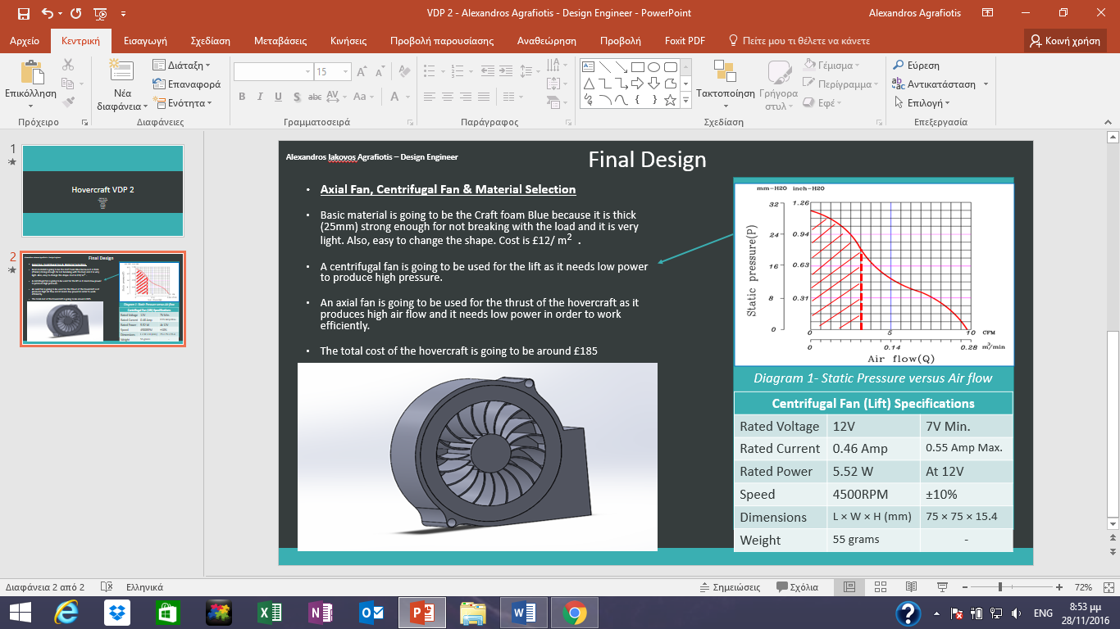

## Powertrain – Keqi Shu

## Turning Mechanism – Paul Longe

Following VDP2 a final design was chosen. It was decided after reviewing the design specification that rudders were the best option as they are easy and cheap to manufacture, require little electrical power to control, and as the fans have a reverse setting the hovercraft is still able to stop as required. The final concept design has dimensions as shown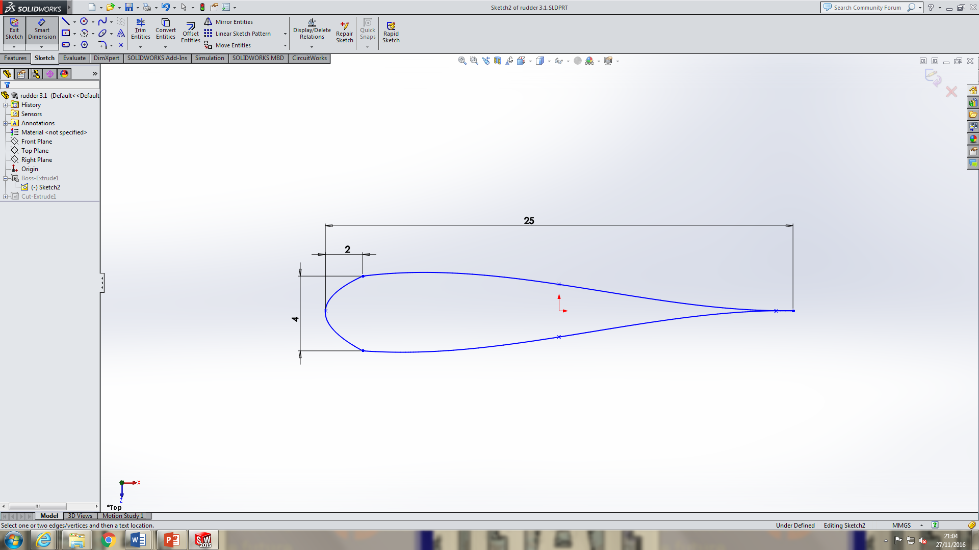, in a symmetrical aerofoil shape to redirect the most airflow possible. The rudders has a depth of 100mm so it covers the whole of the fan area and more airflow can be redirected, the rudder is secured by a pin so it can attach to the cowling and the pin is located in the thickest part where it can bear the most load. Two rudders are to be used because the more rudders there are the greater amount of airflow can be redirected, and by only having two rudders, a large amount of air can be redirected.

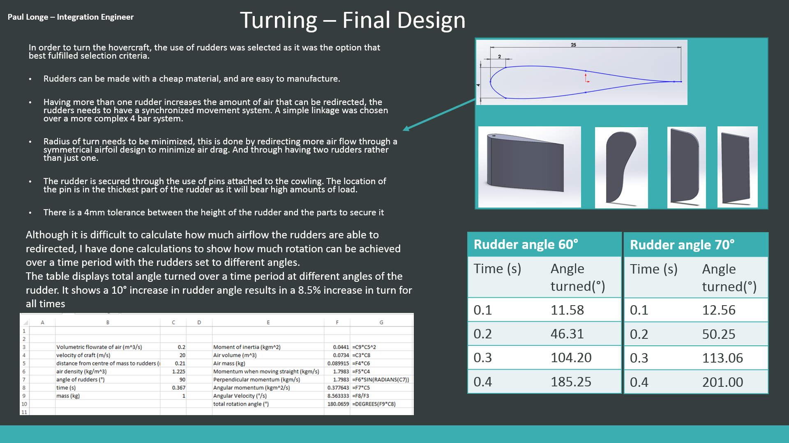

## Electrical Control – Divine Abraham

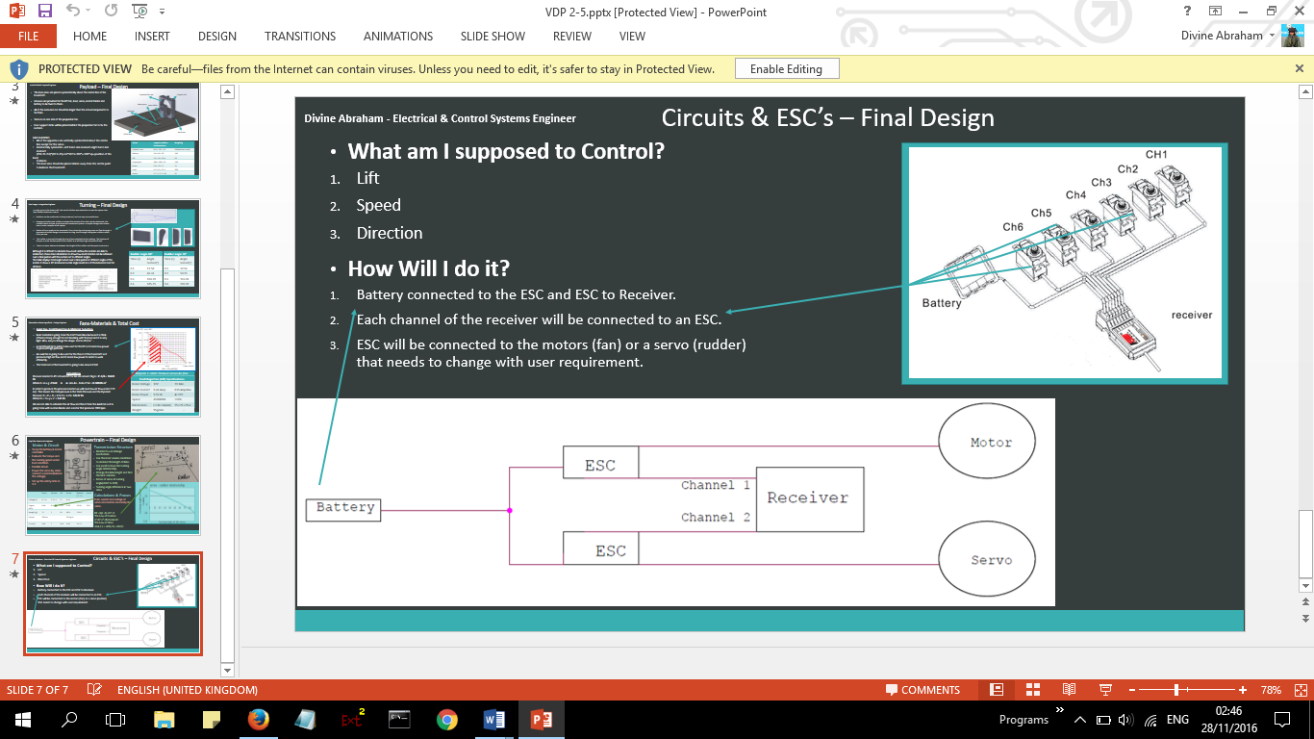

Following on from the feedback received from VDP2, It concluded that an additional circuit be mandatory which will be used to drive the fans in the opposite direction and get the hovercraft to reverse. The rechargeable battery will be directly connected to the electronic speed controllers (ESC’s) using the positive and negative terminals. There’s an intention to use a connector block to connect the nodes to multiple ESC’s . A connection to the motors will be made from the ESC’s and the correct voltage for the motors and servo will be dictated by the receiver which has a 3 pin connection to the ESC.

## Payload Xiang Zhang

The graph below is the final design the payload area.

In order to control the balance of the hovercraft, nearly all the components should be placed symmetrically about the vertical centre line.

There are grooves on the payload area that are used to position the components into the right place. The grooves help to fix the components and save area. Saved area means the total weight will be reduced as well, so we can put more load on the hovercraft. At the same time, all of the grooves should be a little larger than the actual dimension of the components. Because the dimension we found from the website may have errors, 1-2mm larger will help to fix them easier.

The lift fan is placed in the front part; it lays on the vertical centre line of the hovercraft. The hole of the blower is facing to the front. There will be a pipe connect the hole of the blower and the hole of lift fan area, so the blower can blow air to the chassis.

The propulsion fan is placed in the back part. The cowling is designed into square because square is more stable than circle. Four small sticks are stick at the back of the cowling. They are used to fix the rudders.

Servo area is just beside the cowling, because the servo is only 11g, I want to reduce the distance between the centre line and the servo as much as possible. It can be balance when we put the electrical components on as well.

The motor holder is located in front of the cowling. The cylinder area fixes the motor, and the centre of the cylinder is the same height as the centre of the propulsion fan. Therefore, the motor can connect the propulsion fan perfectly. Of course there is a groove under the holder to fit it.

Because of the weight in front and back part are different (shown in the table below), the position area is used to control the balance.

Horizontally symmetric---left hand side moment=right hand side moment

157.5 x 180 + (51+10) x 122 + 48 x 145 = 33 x 92 +200 x 20 x 2 + 200 x X

X =159 mm

